- Click Research Billing Review and select your patient
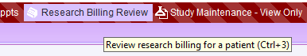

- If you don’t get the account you need to review automatically, select the Restrictions button

- You can select or change the study. If they are no longer active in your study, uncheck the box that says Show only active enrolled studies. You may also specify a time frame, if that would be helpful.
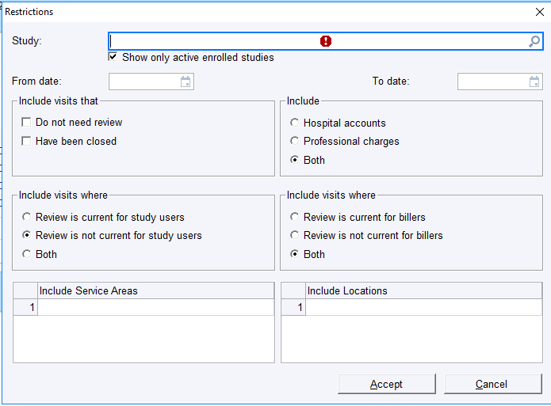

- Change the check boxes to match the screenshot below to search for all accounts. Click Accept and you may then re-review charges.
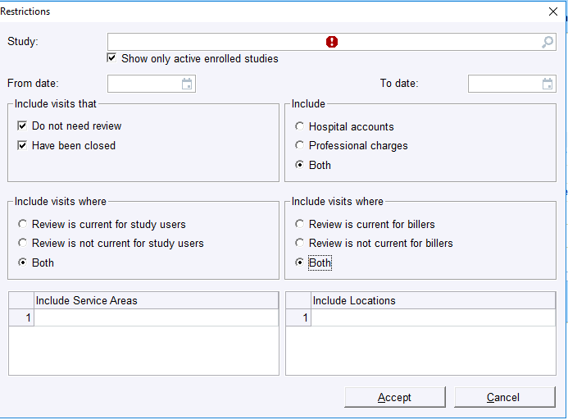
- You may need to click Charges for each encounter to open them.
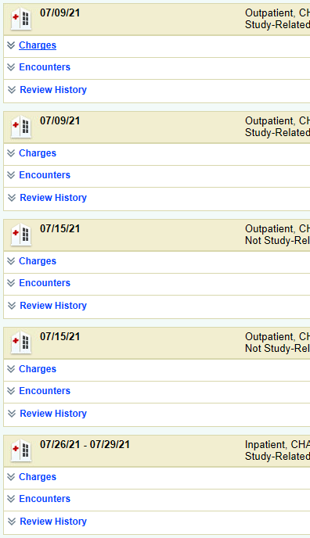
- If you have a checkbox beside the charge you need to move, you may select it and click Research Correction. If you don’t have a checkbox, skip to step 10
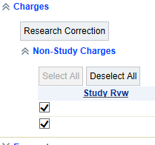
- Fill out the Research Charge Correction box with the correct information, then click Accept
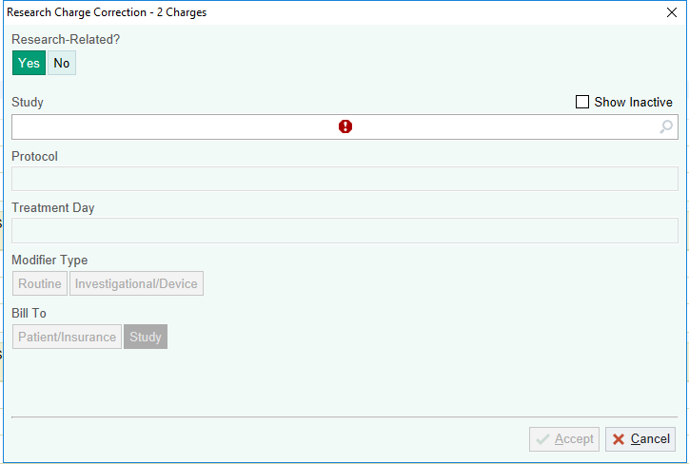
- Click Mark Account as Reviewed
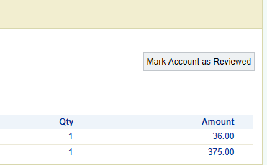
- Type an explanation in the Comment box, then click Accept
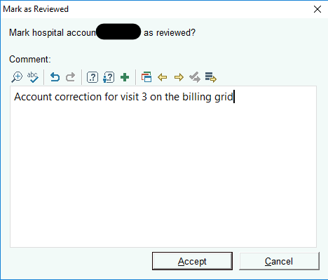
- If your charges do not have checkboxes, you will need to open a ServiceUKnow ticket and a form will be sent to you to complete so that the billing team can make the changes for you. The charges will then come back to your report Total Balance Needing Research Review (Study Team).

